**Doubly Linked List**

**Done By:** Rohit Karunakaran **Roll no:** 58

**Date :** 19-11-2020

**Aim:** To implement a Doubly Linked List and check whether the given string is palindrome

**Data Structure used :** Linked List

**Algorithms**

**1. Algorithm for checking palindrome**

**Input:** A Doubly Linked List with the Head pointing to the first element of the string and the Tail pointing to the last

**Output:** 1 if the string is palindrome 0 if otherwise

**Data Structure:** Doubly Linked List

**Steps:**

1. Step 1: if(Head==NULL)
2. Step 1: print(The list is empty)
3. Step 2: return 0
4. Step 2: else
5. Step 1: i = Header→rlink
6. Step 2: j = Tail → llink
7. Step 3: while(i!=Head and j!=Tail) do
8. Step 1: if(i→data!=j→data ) then
9. Step 1: endWhile
10. Step 2: endif
11. Step 4: EndWhile
12. Step 5: if(i==Head and j==Tail) do
13. Step 1: return 1
14. Step 6: else
15. Step 1: return 0
16. Step 7: endif
17. Step 3: endif
18. Step 4: Stop

**Program code:**

/***************************************

* Program to check whether the given

* string is palindrome using doubly linked list

* Done By: Rohit Karunaran

* *************************************/

#include<stdio.h>

#include<stdlib.h>

typedef struct char_doubly_linked_list

{

struct char_doubly_linked_list *next;

struct char_doubly_linked_list *prev;

char data;

} ddchar;

void initString(ddchar **Header)

{

*Header = (ddchar*)malloc(sizeof(ddchar));

(*Header)->next = NULL;

(*Header)->prev = NULL;

}

void insert(ddchar *Header,char ch)

{

ddchar *newNode = (ddchar*)malloc(sizeof(ddchar));

if(newNode!=NULL)

{

ddchar *Tail = Header;

newNode->data = ch;

if(Header->next == NULL) //That is the string is empty

{

Tail = NULL;

Header->next = newNode;

newNode->prev = Header;

newNode->next=NULL;

}

else

{

while(Tail->next!=NULL) Tail = Tail->next;

Tail->next = newNode;

newNode->prev = Tail;

newNode->next=NULL;

}

}

}

void stringToList(ddchar *Header,char *s)

{

for(int i=0;s[i]!='\0';i++)

insert(Header,s[i]);

}

int checkPalindrome(ddchar *Header)

{

ddchar *i,*j;

if(Header->next!=NULL)

{

i=Header->next;

j=Header;

while(j->next!=NULL)j=j->next; //j becomes the tail pointer

while(i!=NULL&&j!=Header)

{

if(i->data!=j->data)

break;

i=i->next;

j=j->prev;

}

if(i==NULL && j==Header)

{

return 1;

}

return 0;

}

else{

return 0;

}

}

int main()

{

ddchar *str = (ddchar*) malloc(sizeof(ddchar));

initString(&str);

char input[50];

printf("Enter the string to be checked : ");

scanf("%[^\n]%*c",input);

stringToList(str,input);

if(checkPalindrome(str))

{

printf("The String is palindorme");

}

else

{

printf("The String is not palindorme");

}

return 0;

}

**Sample Input/Output**

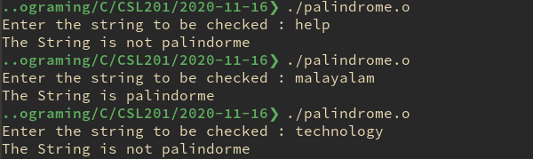

**Result:** the Program compiled successfully and the desired output was obtained.